Artificial Fingers Wearing Skin Vibration Sensor

【Summary】：

We developed a wearable skin vibration sensor and previously showed the availability for texture evaluations.

【Conclusion】：

This article presents a wearable artificial finger with a skin vibration sensor. The method of wrapping the skin vibration sensor is the same as the method of mounting the sensor on an artificial finger. Considering human skin, artificial fingers consist of a rigid base, a soft layer, and a thin layer with ridges on the surface. Artificial fingers with different skin characteristics can be easily replaced. In this paper, artificial fingers with different ridges were prepared, and sensor outputs were collected while rubbing different particle surfaces. The sensor output generally increases with increasing particle size, especially at small sizes. In addition, the output of the sensor has different trends depending on the artificial finger. The height of the ridge affects the strength of the sensor output, and the width of the groove affects the peak frequency and measurement range.

The results show that the proposed artificial finger can be used to evaluate tactile information, and different artificial fingers have different responses reflecting skin characteristics. This suggests that artificial fingers may help customize for target audiences and users to more accurately evaluate objects and reflect the personality of each person ’s finger.

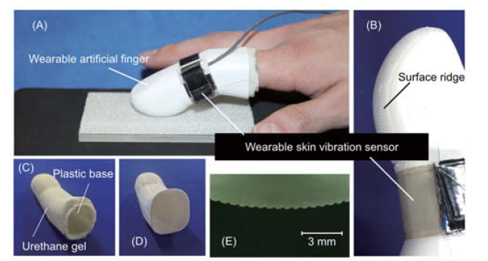

【basic idea】：

1. Compared with artificial fingers, artificial fingers can collect reproducible and stable data. Wearable skin vibration sensors are wrapped around artificial fingers like artificial fingers. Therefore, the results obtained using artificial fingers can be used for analysis and evaluation of artificial fingers.

2. In addition, wearable fingers can take advantage of human motion. People use contact force and scanning speed for tactile perception in exploratory movement. In general, human exploratory movements are difficult to replicate with robotic arms and fingers because they often require multi-degree-of-freedom robotic arms and fingers and complex strategies. Even if robots can imitate such human movements, such robots often require complex and large systems, and during the exploration process, vibrations caused by the movement of the robotic arms and fingers can cause noise problems.

3. From these perspectives, in particular, the base of the artificial finger is designed as a rigid body to prevent human fingers from affecting the output of the sensor. In the future, other sensors (such as pressure and temperature) can be embedded to extend the sensors to evaluate a wider range of haptic information.

【Equipment materials】:

The wearable artiﬁcial ﬁnger consists of a plastic base, urethane gel (HITOHADA gel, EXSEAL), and silicone rub-ber (KE-14, ShinEtsu). The bottom of Fig. 1 shows the base with urethane gel, silicone rubber, and the surface on silicone rubber.